Baby Clothes Bathroom Sinks Bikes CDs Dishwashers  Pianos Refrigerators Sofas Tables Televisions Toasters Washing Machines Vases  Golfcarts Toys Mattresses Waterbeds Coffee Tables | Backpacks Bagels Baggage Balloons Balls Banjos  Baby Clothes Bathroom Sinks Bikes CDs Dishwashers  Pianos Refrigerators Sofas Tables Televisions Toasters Washing Machines Vases  Golfcarts Toys Mattresses Waterbeds Coffee Tables
  Blankets Books Cabinets Cell Phones Computers Couches Desks Dryers Frames
  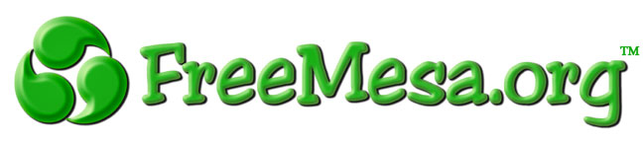Awesome stuff, for free.
  Need Something?
  Have something to give away?
  Where people go to give and receive things for free.
  Go To FreeMesa.org
  Blankets Books Cabinets Cell Phones Computers Couches Desks Dryers Frames
  Belts Benches Bikes Blenders Boards Books Bowls
  Awesome stuff, for free.
  Need Something?
  Have something to give away?
  Where people go to give and receive things for free.
  Go To FreeMesa.org

