Introducing <<school name>> on


The Recycle Swap Stop for <<school name>>!
<<URL>>

Instruction Guide

What is FreeMesa.org?

FreeMesa.org is an online community of people working to make the world a better place by giving things away. Members both give items to and receive items from other members in their local community all for free.

The items being given away are still perfectly good, but are just in need of a new home. FreeMesa.org helps the owners find one for them. In this way, clutter is reduced, money is saved, and the landfill is spared.

Why Have a Group?

The <<school name>> group on FreeMesa.org creates an online community for the school; and this new community provides many benefits to both the parents and the school. Specifically the group now lets the parents:

- Connect the community together
- Easily find needed things for the classroom
- Quickly find a new home for outgrown clothes, toys, furniture, etc
- Save Money with Free clothes, toys, & things
- Using the group Raises Money for the school

How Does it Work?
- Lets take a quick tour and go through the process of giving something away.

The Home Page

<<URL>>

This is the Group Home Page. The first time you come here, you will need to create an account. This can easily be done by clicking on the ‘Create an Account’ link at the top of the page.

After filling out a short form, an account is created for you. After that first time, you’d just need to enter your login and password in the upper right form to continue.
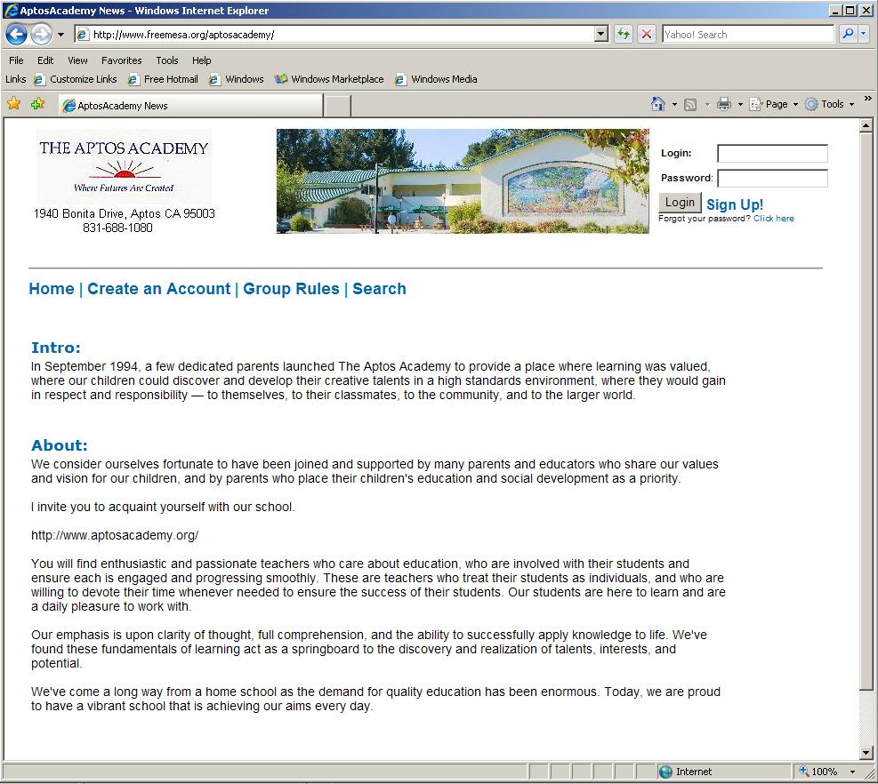

The Forum
Once you log in, you will be brought to the Offers & Requests forum. This is the list of all of the Items currently available on the group site.
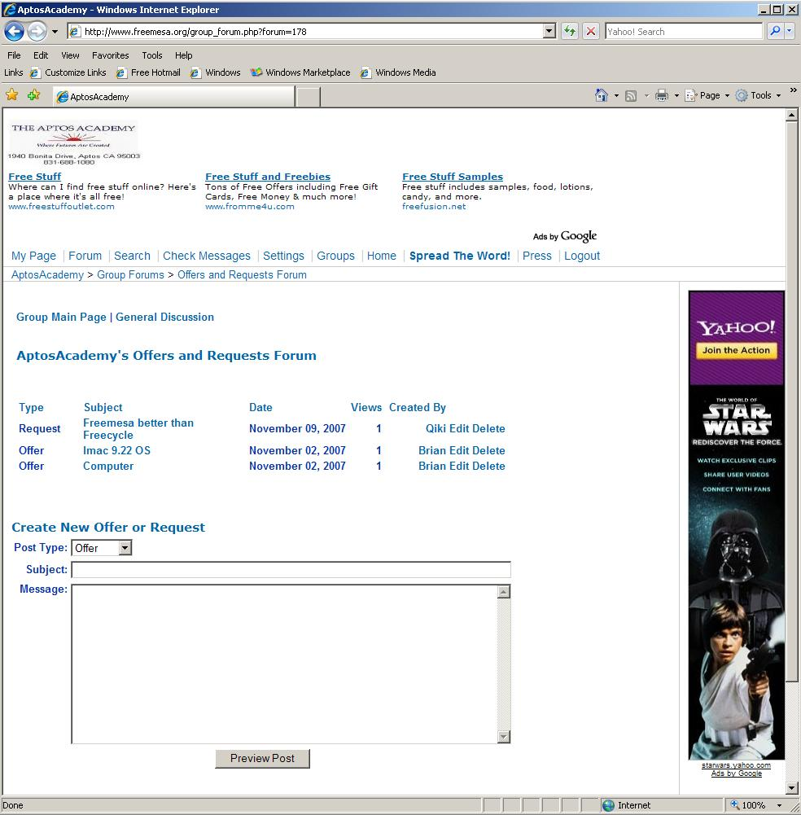

Posting an Offer
If we wanted to post an Offer to give away an item, say a 15” computer monitor, for example, we could enter this information into the form at the bottom of the page. When we are done, we click the ‘Preview Post’ button. The image below is what the preview should look like after we are done.
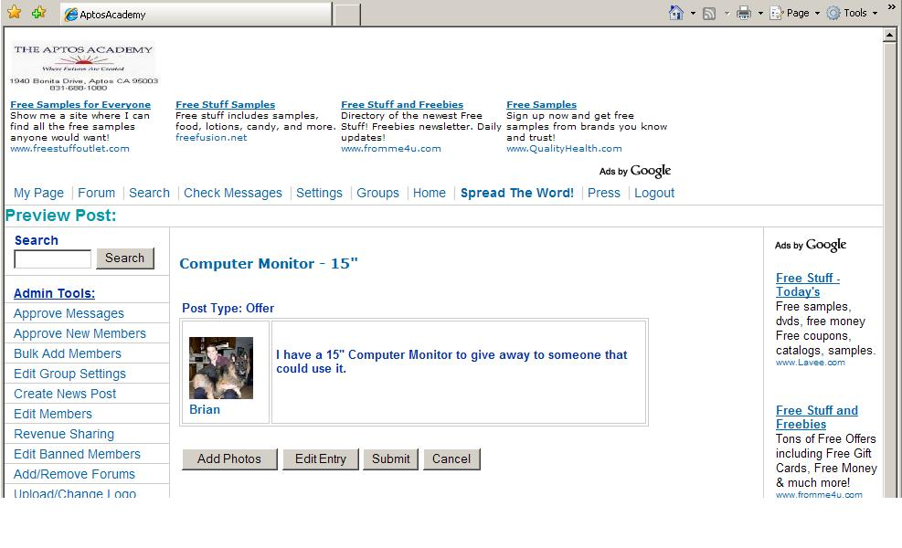

Adding Photos

We have a photo of the item we would like to upload with the post, so we click the ‘Add Photos’ button, browse to where the picture is, and click ‘Upload Photo’. This is what the post should look like after we have done this.

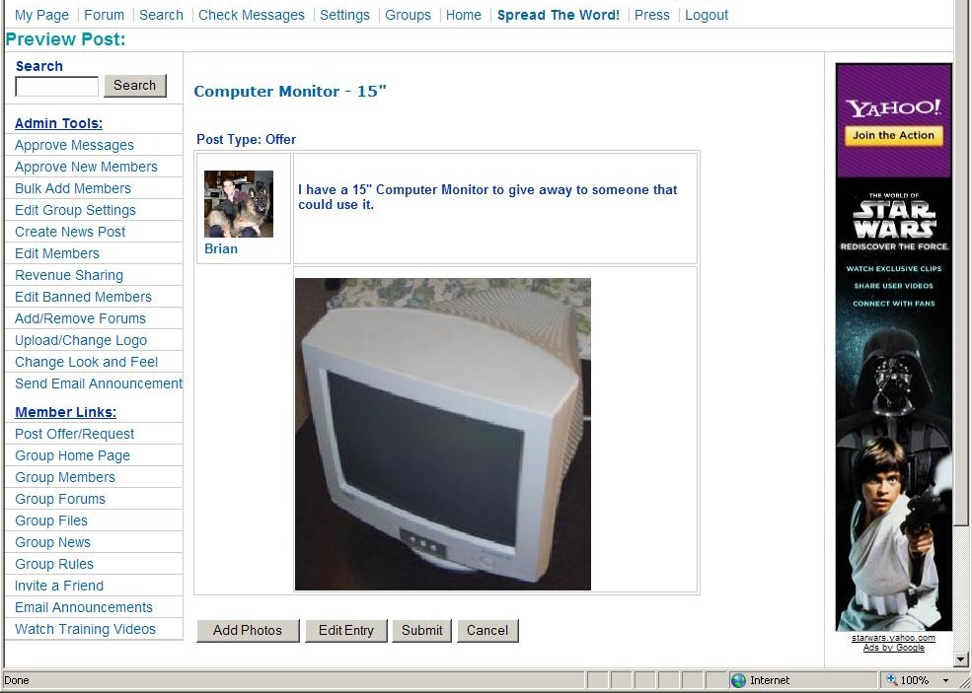

Submit!

Since the post is looking pretty good, we click the ‘Submit’ Button. The post is now successfully created for everyone to see. In the image below, you can see that the ‘Computer Monitor –15”’ has been added to the top of the list of available items.
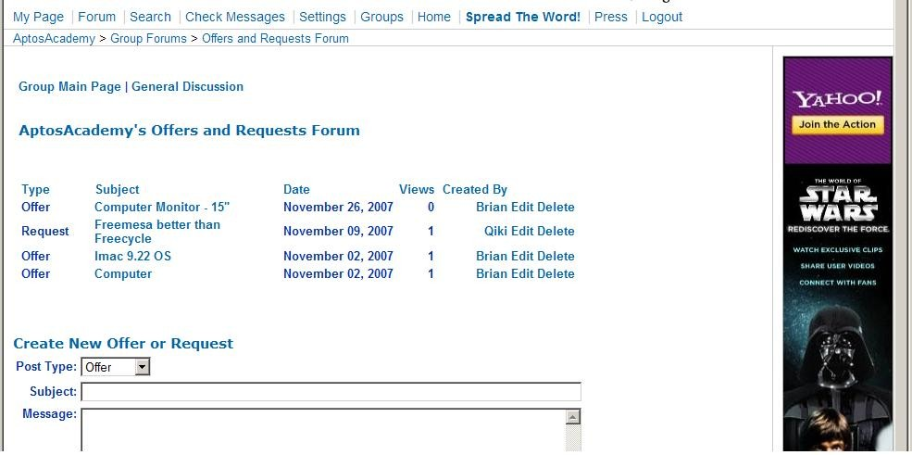

So What Happens Now?
That night an email containing the list of all the offers and requests of that day is emailed to the group members. This email also contains a link that will automatically log them into the group and brings them to the forum.

Viewing the Post

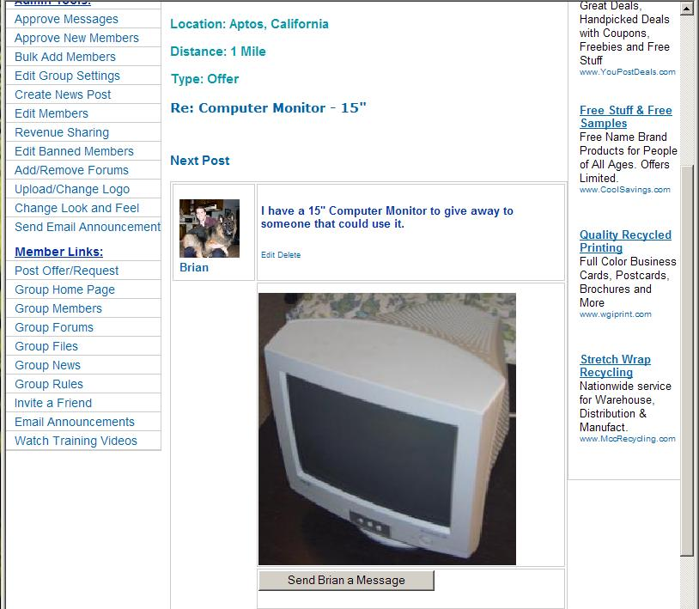
After we have gotten the email and see that there is the offer of a 15” Monitor that is available that would be just perfect for a spare computer we have, we click on the link in the forum and see the post below. Also notice that there is an estimated distance between you and the item listed on the post. This is based off of zip code, and gives you an idea of how far you might need to drive to pick the item up.

Sending a Message

If the item looks like something we might want, we can send the poster a message by clicking the ‘Send a Message’ link at the bottom of the post, which should bring up this page below. In it we can send the poster a message asking if the item is still available, or for more information about the object.

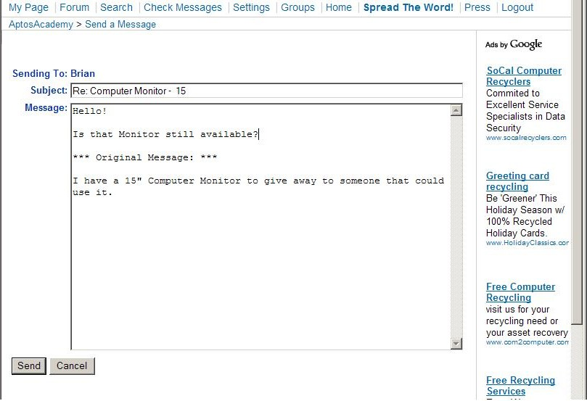

What Happens Now?

After we send the message, the poster will get an E-mail, and from here on out the members are in direct contact and can exchange contact information and arrange pick up of the object.

This allows the giver to clear up some space and get rid of something they no longer need, it saves the recipient money since they don’t have to go buy something brand new, and it saves the landfill from having to store yet another item. Everyone wins!

How Does it Raise Money for the school?

Ad Banners & Revenue Sharing!

FreeMesa.org helps schools & non-profits raise money with a revenue sharing program. A certain percentage of the time, Ads benefiting FreeMesa are displayed, and the rest of the time, ads benefiting the school or non-profit are displayed.

There are two options that are offered – Google’s AdSense, and Custom Campaigns.

Google’s AdSense is a program with Google where they select and display ads automatically. There is no work required on the part of the school to find advertisers or maintain the ads. Google does it all, and deposits the money into the organization’s account. The Ads are always family friendly and appropriate. This is the same program that FreeMesa uses to display ads.

Custom Campaigns let the organization make private arrangements with local businesses to display their own Ad banners. These agreements are entirely between the local businesses and the organization, and the group can upload and maintain their own banners – FreeMesa never touches the money.

Ads Look Like this:

Online Demos

FreeMesa.org has online videos showing how the groups work, and the features they have. You can check them out here:

Using the Groups:
http://www.freemesa.org/groups

How to Create and Set Up a Group:
http://www.freemesa.org/groupdemo

Using FreeMesa.org at large:
http://www.freemesa.org/demo

